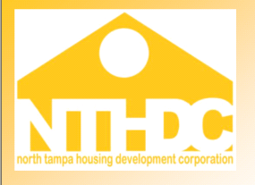

Fax
To: |  | From:
Fax: |  | Pages:
Co.: |  | Date:
Re: |  | CC:

Dear Owner/Agent:

While processing your HAP request, it has come to our attention that (Tenant Name) __________________

has been receiving subsidy simultaneously at the below identified properties.

A. Property Name: | B. Property Name:
Unit # | Unit #
Effective Date: | Effective Date:

In accordance with HUD guidelines, 4350.3 3-10, double subsidy is prohibited. NTHDC must, therefore, determine the obligation of each owner to repay the overpaid subsidy.

Please answer the following questions and supply any supporting documentation you may have including the MO inspection form.

1. Did management/resident review and acknowledge Paragraph 13 of the lease at move in? Yes No

2. Did the resident identify currently living in subsidized housing @ move in? Yes No

3. Did the resident give notice of moving out, if so what date?_________ Date keys turned in?________

4. What date did management discover the unit was vacant?________________

4. Was or will a unit inspection take place to determine occupancy? _________

5. Is the tenant subletting the unit?_______ Was the unit abandoned? __________

6. Is there a reason the return key date does not match the move out date? ___________________________

Please complete the above and fax to 813-877-1412. Thank you.

